DHOLA MAHAVIDYALAYA
P.O. + P.S. - Dholahat, South 24 Parganas, West Bengal -743399
Website: www.dholamahavidyalaya.in

Notice
(Admission for Phase-II/ 1st Merit List to B.A. Semester-I for the Session 2019-2020)
And for BNGA Course according to the Phase –I List
Dated: 01.07.2019

Online admission (E-Counseling) for Phase-II to B.A. Semester-I(Under Choice Based Credit System), Honours-HISA,GEOA,ENGA, and General Course (According to Phase -II Merit List) and for BNGA according to (Phase-I List) for the session 2019 – 2020 will be continued as per following schedule through the college web address www.dholamahavidyalaya.in or admissiondm.in

Admission Fees:
As mentioned in the website under Important Notice section in the notice Courses Offered.

Regarding Payment:
Students have to pay online to the College Account only through Online Payment mode by Debit Card/Credit Card/Net Banking and Wallet.

***Students should check their respective data several times before final submission of application forms, as there is no scope for rectification after final submission. ****

SL No. | Activity | Date
1 | Honours-BNGA Course According to Phase –I applicants admission & pay fees within |  | 02-07-2019
2 | For HISA,GEOA,ENGA, and General Course (According to Phase -II List) admission & Pay fees within | 04-07-2019
3 | Any further List Publication for Bengali Honours Course (If required) | 03-07-2019

Students are asked to follow further notification after publication of Merit List for admission.

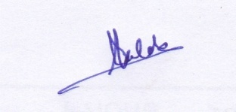
Teacher-in-charge
Dhola Mahavidyalaya

