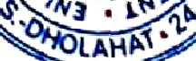D
P.O. + P.S.- Dholahat, Dist. - South 24 Parganas,
West Bengal, Pin.-743399
Website: www.dholamahavidyalaya.in e-mail: dholamahavidyalaya@gmail.com
z

Notice

All present students of Dhola Mahavidyalaya (Hons as well as General) are asked to fill up this Google form (link given below), giving the required data accurately.

https://forms.gle/gxsJKCQ7BExYfa1y9

Note: A student can find his/her College ID in any payment receipt made during fees payments related to the college.

Dated: 13.04.2023

